HISTORIC PLACES WELLINGTON INC
PO BOX 12426 THORNDON WELLINGTON
Wellington 6144

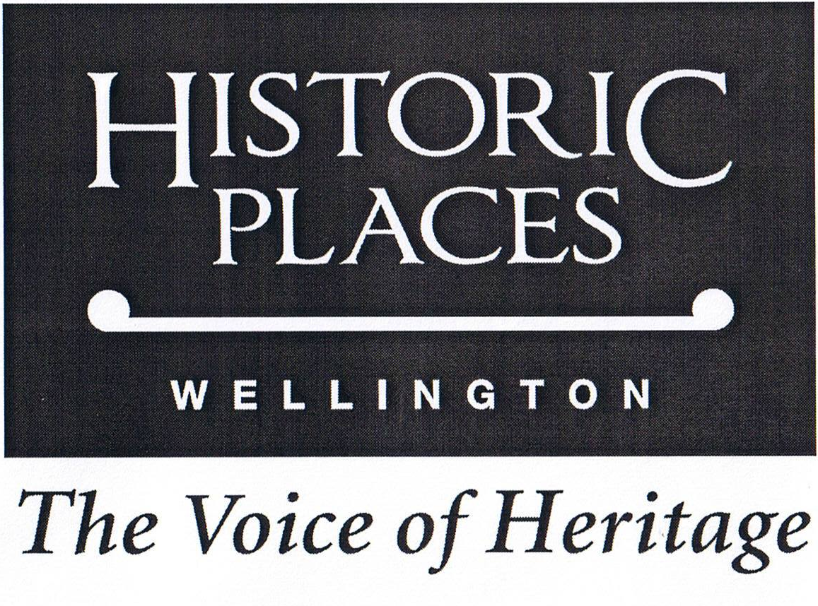

Newsletter

No. 1. September 2012

NOTICE OF THE FIRST ANNUAL MEETING
MONDAY, 17 SEPTEMBER 2012, AT 5.45 PM (Refreshments from 5.15 pm)
AT ST ANDREW’S HALL, 30 THE TERRACE, WELLINGTON CITY
(Access to the right of the church)

PLEASE NOTE CHANGE OF VENUE
due to the recent closure of Turnbull House

The meeting will be followed with a talk by Iona Pannett, Wellington City Councillor and Portfolio Leader: Built Environment. Iona will talk about the Council's role in heritage, followed by an open discussion about Wellington heritage issues, and what you would like to see our organisation doing.

Please come to the meeting and support our new heritage organisation. This is a challenging time for heritage, with earthquake issues uppermost. Don’t miss this opportunity to hear about heritage from the Council’s perspective, and discuss the future of heritage in our city.
Please bring this newsletter as it contains material for the meeting

MEETING AGENDA

Apologies
- Chairman’s report
- Treasurer’s report and financial statement
- Election of Committee
- Election of Honorary Reviewer
- Notices of Motion for Historic Places Aotearoa Annual Meeting
- Appointment of representatives to Historic Places Aotearoa Annual Meeting
- General business

TRANSITIONAL COMMITTEE CONTACTS

John Daniels | Chair and General Policy.  While we have managed the transitional period with a small committee, it is evident that more people and a wider range of skills would be beneficial. In particular, we are looking for people with architectural skills, heritage experience and someone to assist with trips.  If you are interested please contact John Daniels by phone or email. Nominations can also be taken at the meeting.  04 9387971 jr.daniels@clear.net.nz
Tania Warburton | Secretary, Legal and Charity Status
Peter Dowell | Treasurer and Property Sector Liaison
Joanna Newman | Advocacy and Registration
Graeme Ross | Outer-City Liaison
Priscilla Williams | Advocacy and Registration

CHAIRMAN’S REPORT

This is the first Annual Meeting of our new heritage organisation, Historic Places Wellington Incorporated, and it marks a milestone in community heritage endeavours. It is a pleasure to welcome all of our new members - thank you for joining. Our new society was launched in style by the Governor-General at Government House on 14 August. This was also the launch of Historic Places Aotearoa, the new national heritage body to which we are affiliated.

Our society has grown out of and is the successor to the former Wellington Branch Committee of the New Zealand Historic Places Trust (NZHPT). The branch committee did sterling work for heritage over seven decades, and we hope that we can build on their work.

Historic Places Wellington has the following objects:
(a) To promote the identification, protection and conservation of historic places in the area of the Society, for the benefit of those communities and the general public.
(b) To inform, advise and educate the public, including stakeholders, of the significance of the area’s historic places.
(c) To work in conjunction with Historic Places Aotearoa Incorporated, the New Zealand Historic Places Trust, and other Regional Societies, local and central government agencies to create better understanding and awareness of the importance of heritage in the Society’s area.

Following the announcement that the NZHPT branch committees were to be abolished, moves began to create a new regional heritage body. The idea received support at a meeting of historical and like societies in August 2011. From that stage the branch committee decided to proceed with forming a new body and began to act as a transitional committee for Historic Places Wellington in tandem with its branch committee role. Rules were adopted by the then members and incorporation applied for. This was granted in early July this year. The rules are circulated with this newsletter.

We negotiated with the Historic Places Trust to phase out the branch committee and this was completed in June this year. The Trust transferred to Historic Places Wellington the branch committee funds totalling $12,500. We are grateful to the Trust for this support.

Following this transition we emailed those NZHPT members for whom we had contact details. As a result 168 members have joined us, and $6,420 in subscriptions and $640 in donations have been received. A special thank you to those who gave us donations.

The committee decided that Historic Places Wellington should affiliate with the national body Historic Places Aotearoa, and this has been effected. As reported above, both bodies were formally launched on 14 August. The arrangement with HPA has the practical value of providing us with centralised membership processing. All subscriptions are paid to HPA, which forwards them to the relevant regional societies after deducting an amount for central operations.
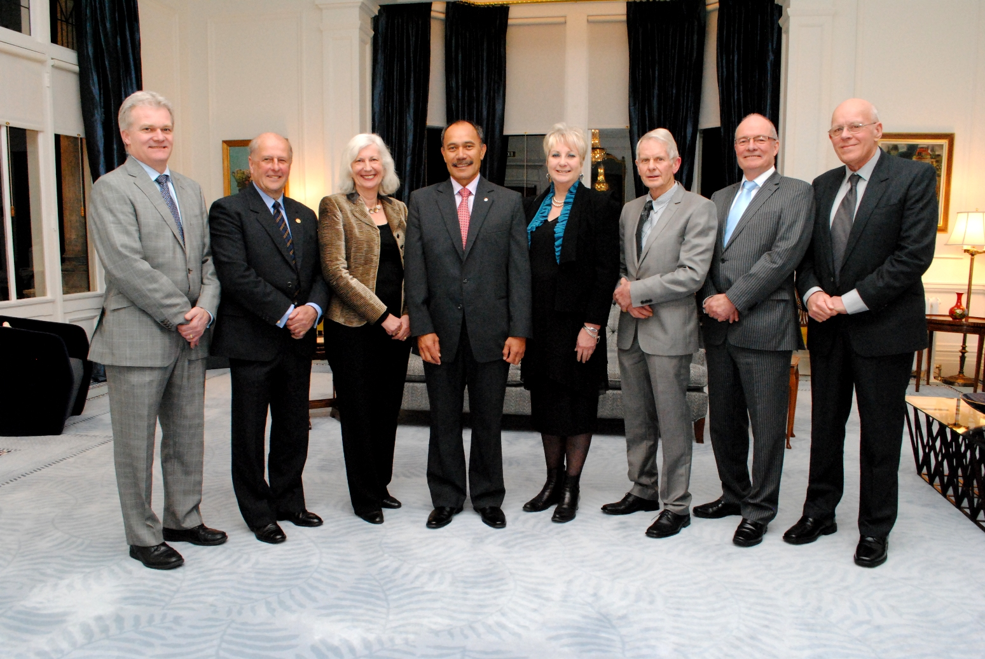

The official party at the launch of Historic Places Aotearoa and Historic Places Wellington at Government House 14 August 2012. Peter Dowell, David White, Dame Anne Salmond, Sir Jerry Mateparae, Anna Crighton, Dennis Pilkington, David Kiddey, John Daniels.

Photo - Government House
We have a good range of skills on the transitional committee, including heritage management, historical research and advocacy, legal, commercial property, and regional heritage affairs. We do, however, need more members to share our work, and any offers will be welcome. Another challenge is to ensure we represent adequately the whole region which covers the local authorities of Wellington, Hutt City, Upper Hutt, Porirua and Kapiti.

Elsewhere in the newsletter we describe our work over the past few months and these give a small indication of the breadth of issues with which we need to deal in the future. The major issues of seismic risk, economic pressures on heritage building owners, major roading projects and possible changes to building controls all pose large challenges to the heritage sector. Some local authorities are responding to these challenges by seeking to limit their heritage involvement, and we need to respond to this also.

The committee is very aware that membership is our life-blood. Members have supported the branch committee loyally in the last and we will work to build that same level of support for Historic Places Wellington. We plan to provide a range of interesting and rewarding activities for our members, beginning early next year. We welcome ideas from members about activities you would like us to provide. This meeting is an opportunity to put these ideas forward.

Finally, I would like to thank the committee, our members, and all our partner organisations, particularly the NZHPT Central Regional Office, for their support, hard work, and encouragement during our first year.

John Daniels
For the Committee

WHAT HAVE WE BEEN DOING IN THE PAST FEW MONTHS?

Historic Places Aotearoa

We have assisted HPA with advice on a number of matters, including their launch and their submission on the Heritage New Zealand Bill (see also below). Peter Dowell is a member of the HPA executive.

New Zealand Historic Places Trust
We have maintained a co-operative working relationship with the Trust and will form new links now that we are fully in operation. The Trust will be an important partner in our heritage work.

Wellington City Long Term Plan (As NZHPT Wellington Branch Committee)
We submitted on a range of issues including seismic strengthening, roading, and assistance to heritage building owners.
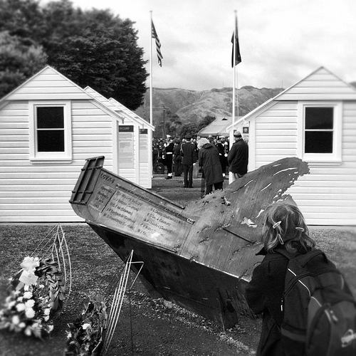

US Marines 70th Anniversary
(As NZHPT Wellington Branch Committee)
We arranged for a grant from NZHPT project funds for refurbishment of display panels at the site of the Paekakariki Marines Camp, and representatives of the committee attended the celebrations there on 28 May 2012.

The photograph shows, in the background, the outdoor display panels in the shape of men's huts. In the foreground is a monument to men drowned in a landing craft accident off Paekakariki Beach.

Photo - US Embassy New Zealand

Mount Street Cemetery

We supported an application by the Friends of Mount Street Cemetery for lottery funding for fencing and signs in the cemetery.

Heritage New Zealand Bill
This Bill, which revises the present Historic Places Act, is before a select committee of Parliament. The Bill changes the name of NZHPT to Heritage New Zealand, and makes a number of changes including abolishing branch committees. We assisted in preparing a submission on the Bill by Historic Places Aotearoa, and also made our own submission. Both submissions focused on the issue of whether Heritage New Zealand, as a Crown Entity, should continue as a membership organisation.

Hutt City Council Petone Plan Change
We made a submission to a proposed change to the Hutt District Plan altering the controls over development on the Petone West commercial area. Our submission drew attention to the risk of adverse effects on the Jackson Street Heritage Zone and the need to mitigate these.

Wellington Harbour Board Historic Area and Wellington Harbour Board Wharf Gates, Posts and Railings (NZHPT Register Proposals)
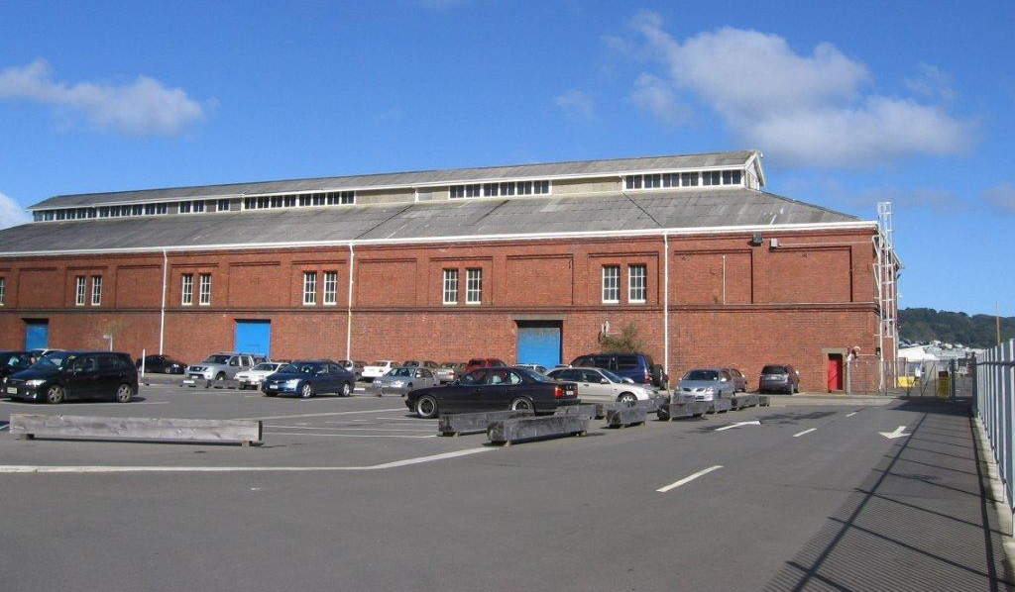
We commented on these proposals from the Trust. The first is a revision of an earlier registration. We supported this and recommended that consideration be given to registering some individual buildings in the area not presently registered. In the second case we drew attention to items stored at Seaview which are part of the heritage of the harbour area.

HERITAGE MONTH – SEPTEMBER

Pick up a pamphlet from your local library about Heritage Month. With the theme of Our Heritage – Our Stories, this publication lists the many displays and events throughout the Wellington region (and the Wairarapa) during September and focussing on heritage. The publication is produced by the Wellington Region Heritage Promotion Council.

JOIN US

To join Historic Places Wellington
or learn more about
Historic Places Aotearoa,
go to
www.historicplacesaotearoa.org.nz

Or contact John Daniels 04 9387971
Photo - Priscilla Williams

Former Harbour Board Wharf Shed 35 Pipitea Wharf, a candidate for future registration by NZ Historic Places Trust.

